**Case study – ELB, ASG and Route 53:**

Three EC2 instances are created:

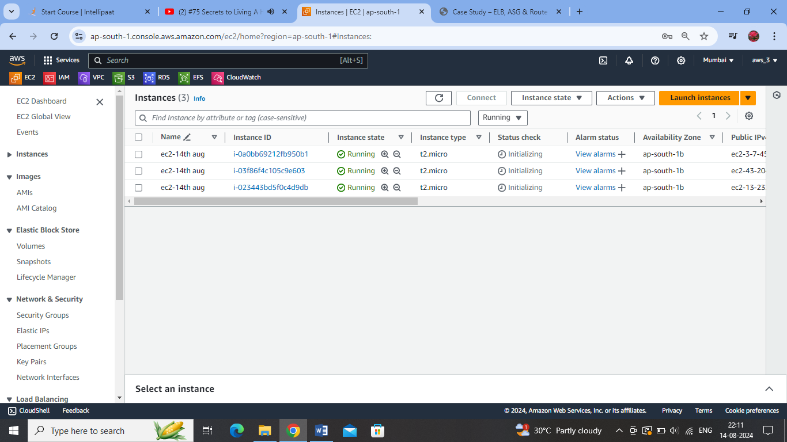Target group created:

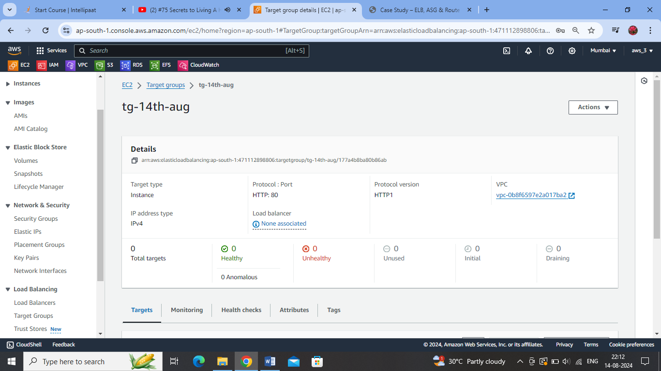

Registering the EC2 instances with the Target Group:

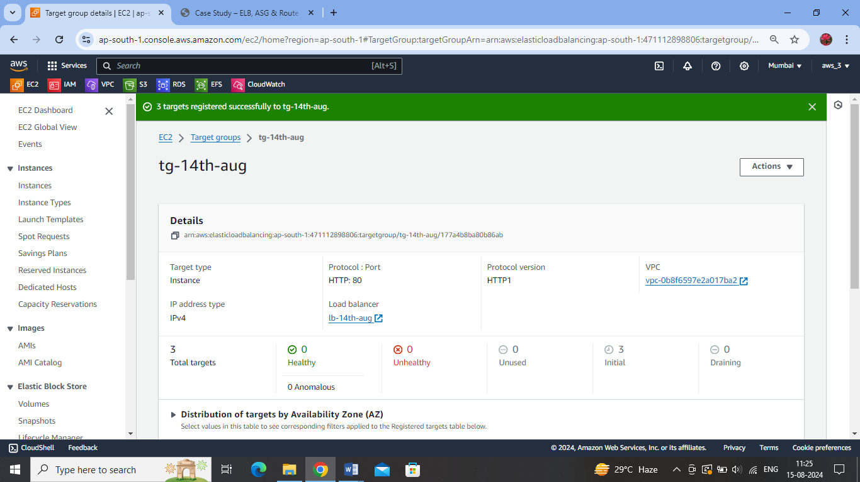

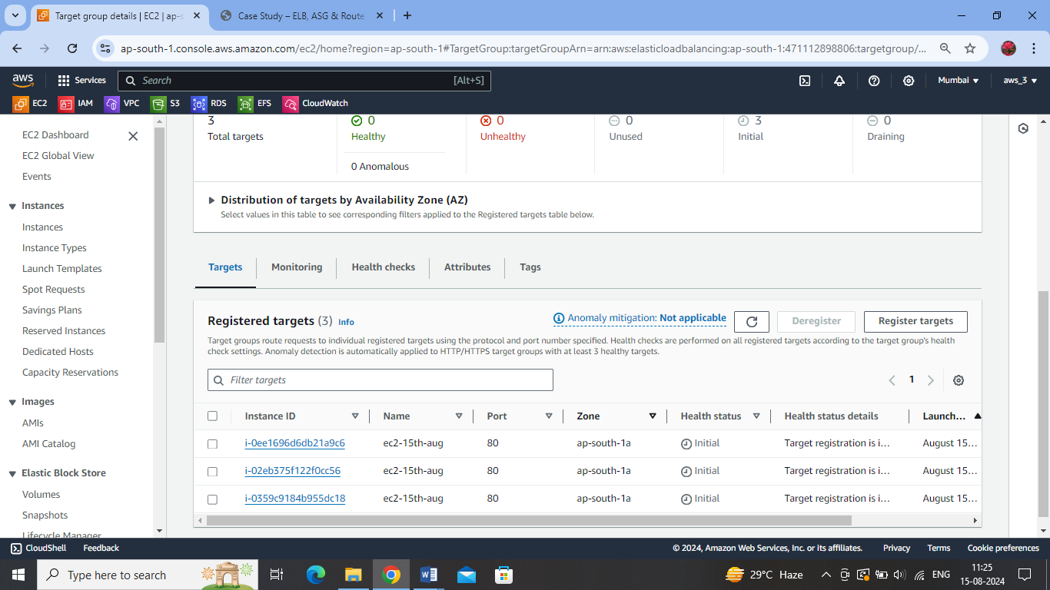

Creating a load balancer for the Target Group :

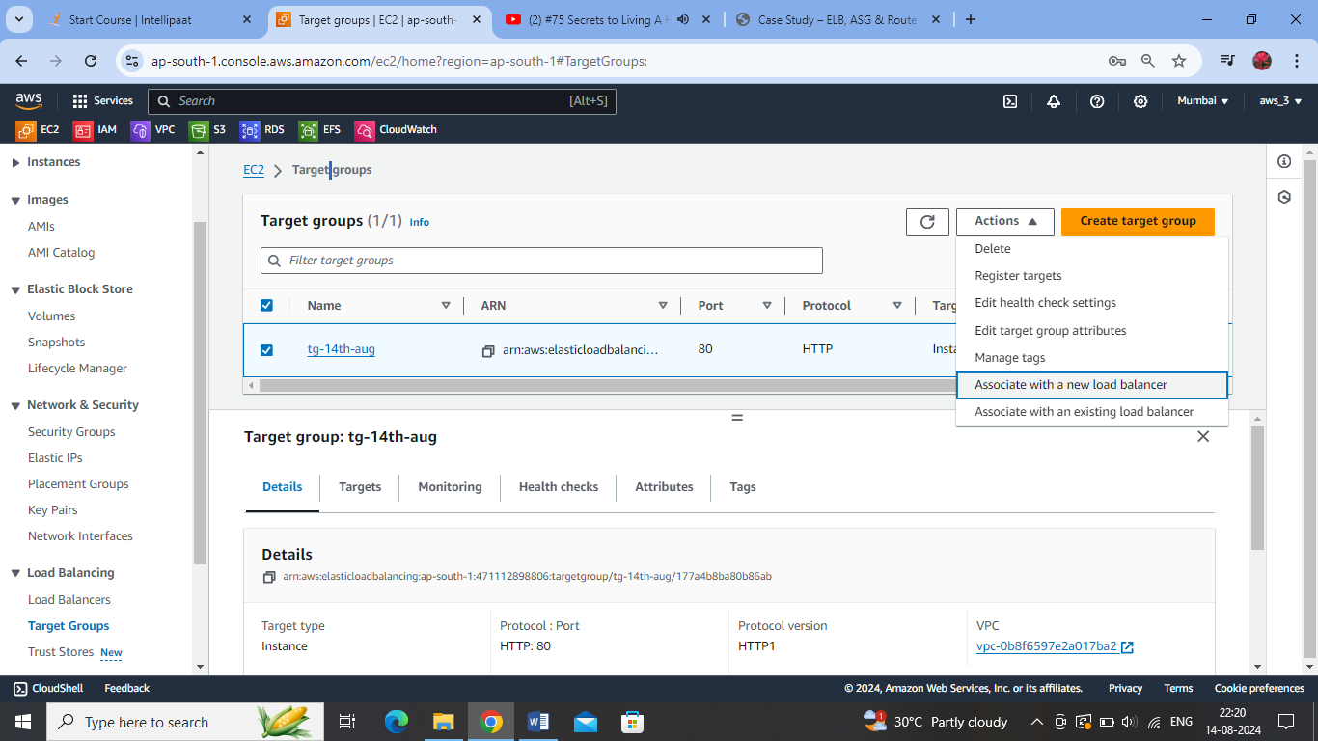

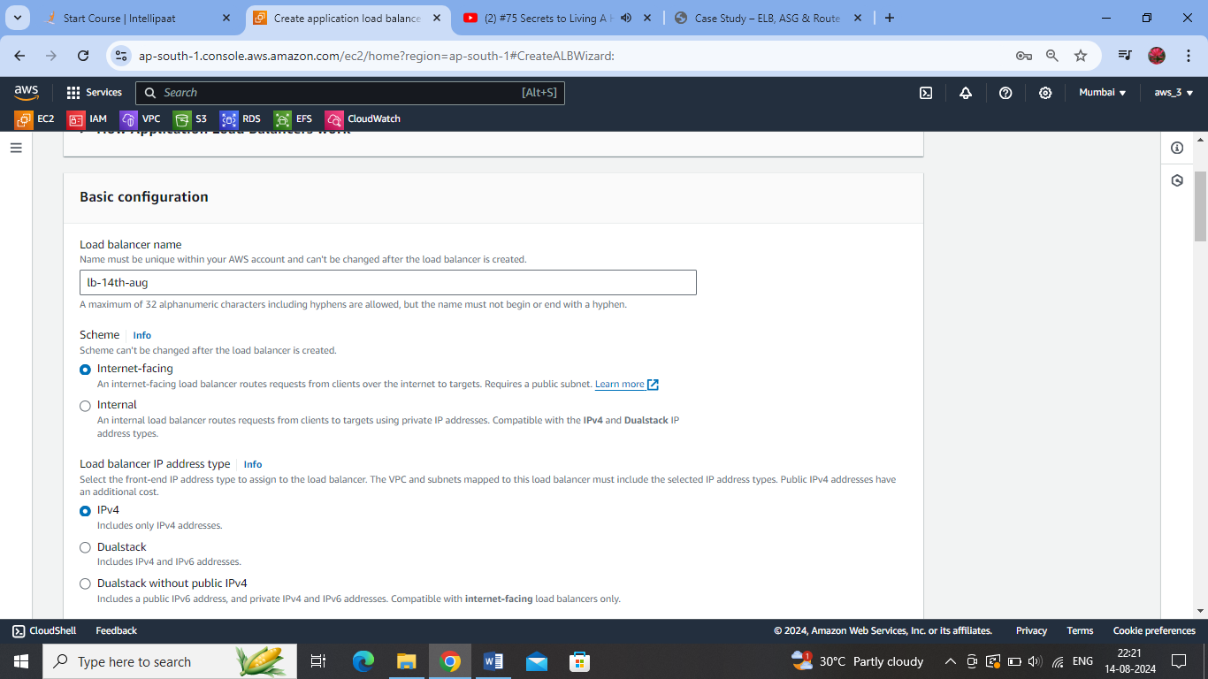

Allowing mapping of target EC2s in all AZs of the Mumbai region :

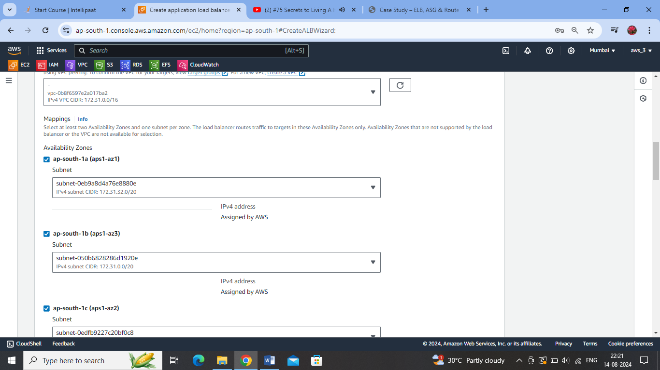

Attaching the Target group to the load balancer – http 80 for listening :

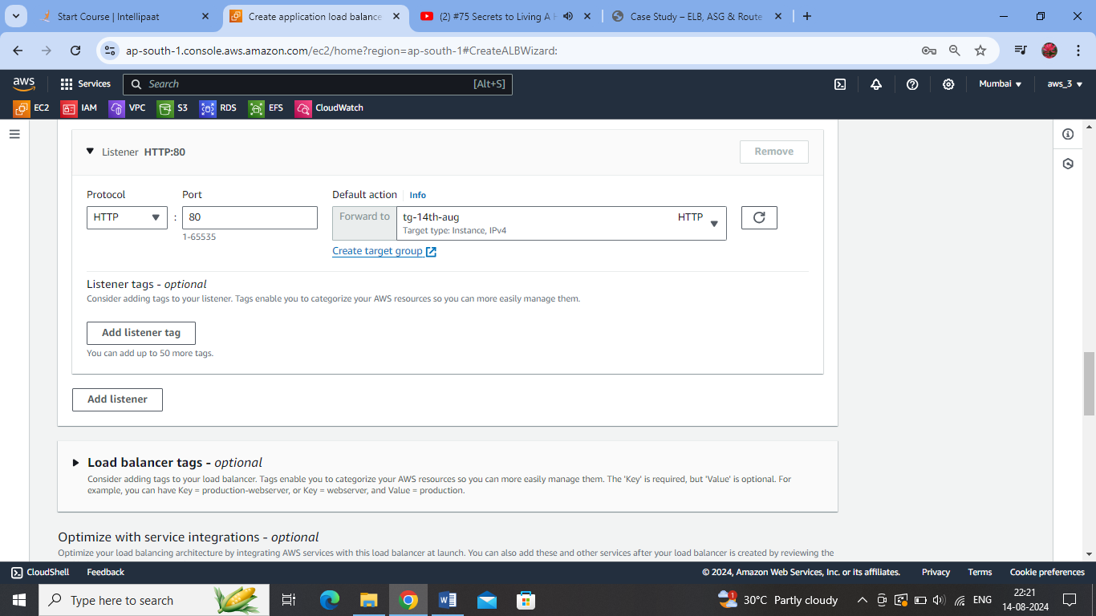

Auto Scaling Group – requires a launch template – (configuration details of instance types to be created during time of scaling out)

Launch Template Created for ASG:

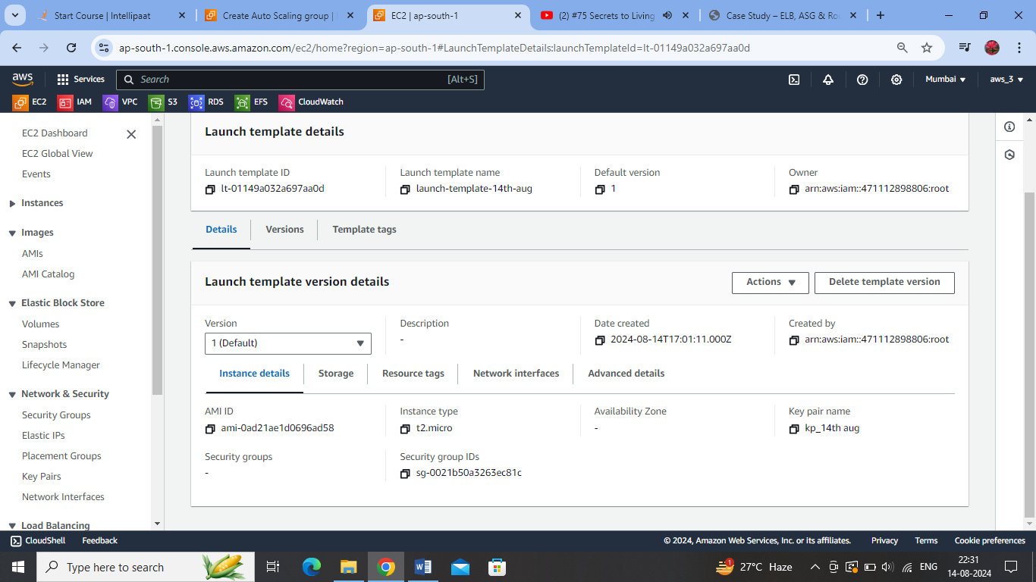

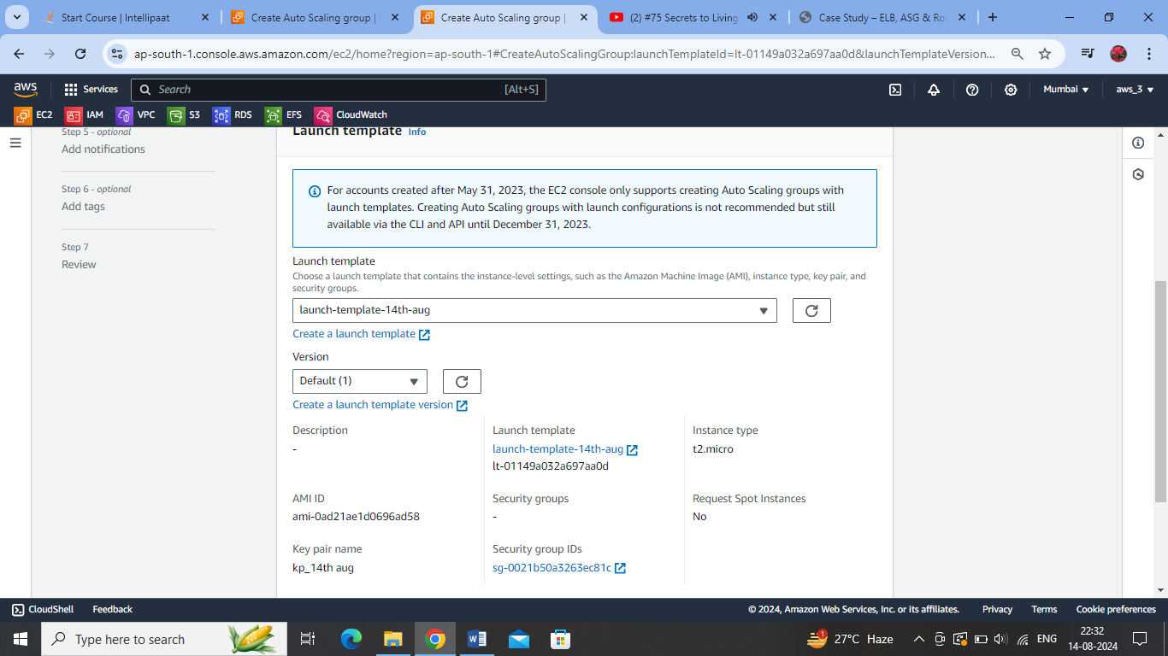

Allowing ASG to create new instances in all AZs of the Mumbai region:

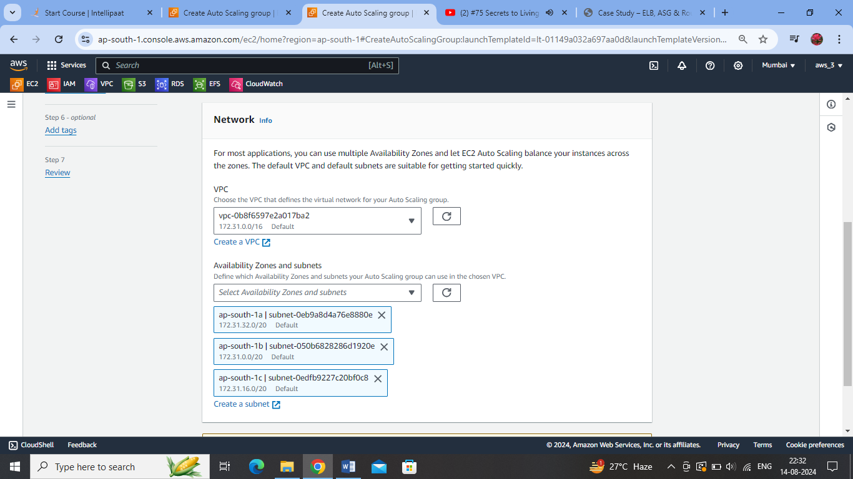

Attaching the current load balancer to the ASG:

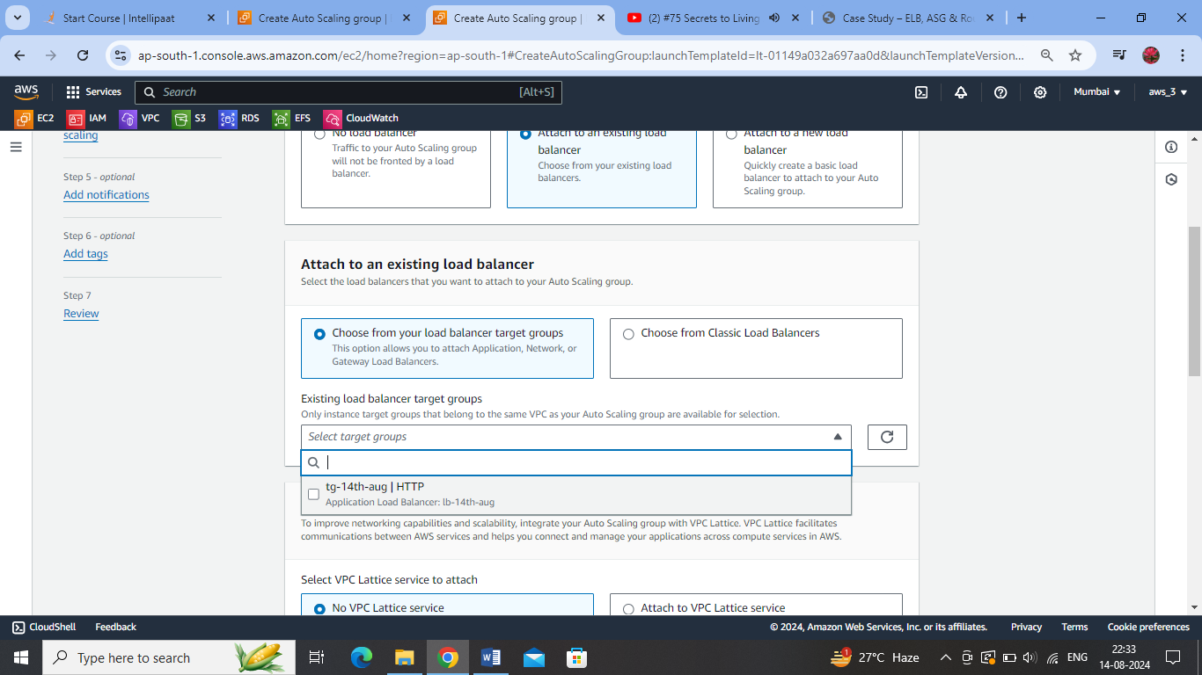

ASG creates EC2 instances:

Since desired capacity is set to 2, two EC2 instances are created initially.

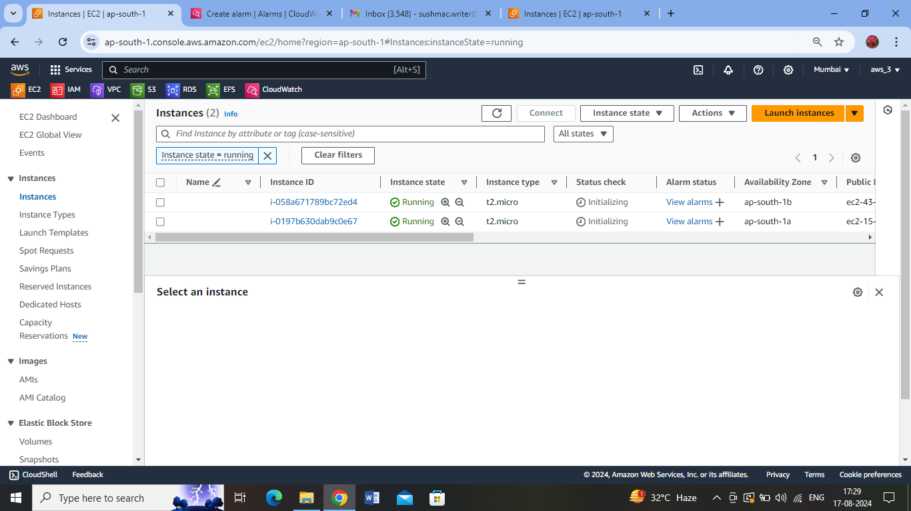

Creating a Cloud Watch Alarm (step-scaling policy)

for the ASG to automatically scale-in and scale-out when the threshold reaches <=60% and >=80% respectively:

Selecting CPU Utilization as the metric.

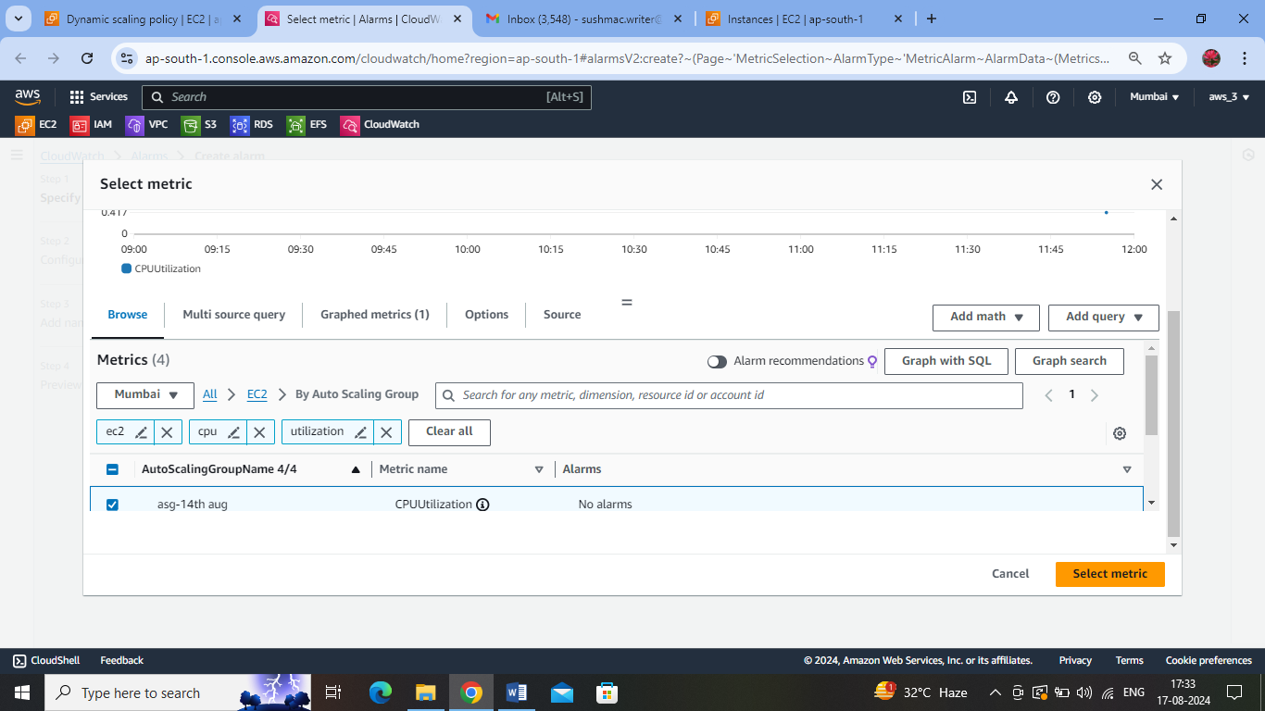

First Alarm: Keeping the average CPU utilization threshold as >=80% :

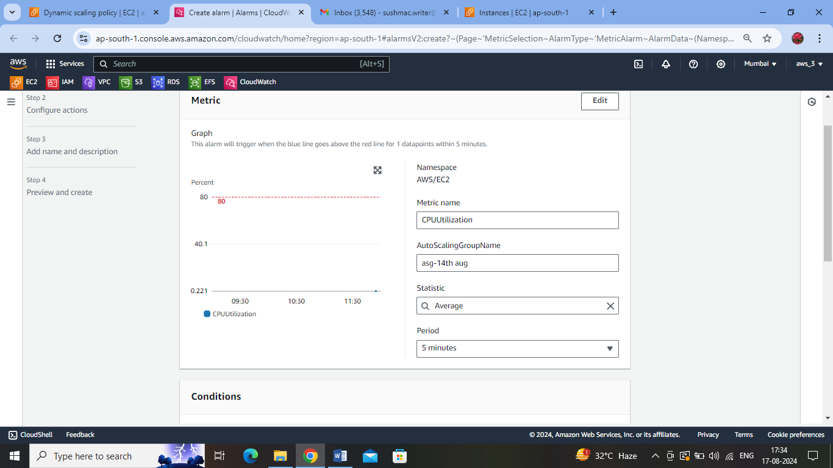

Setting up Notification Action on CPU utilization crossing threshold of 80%:

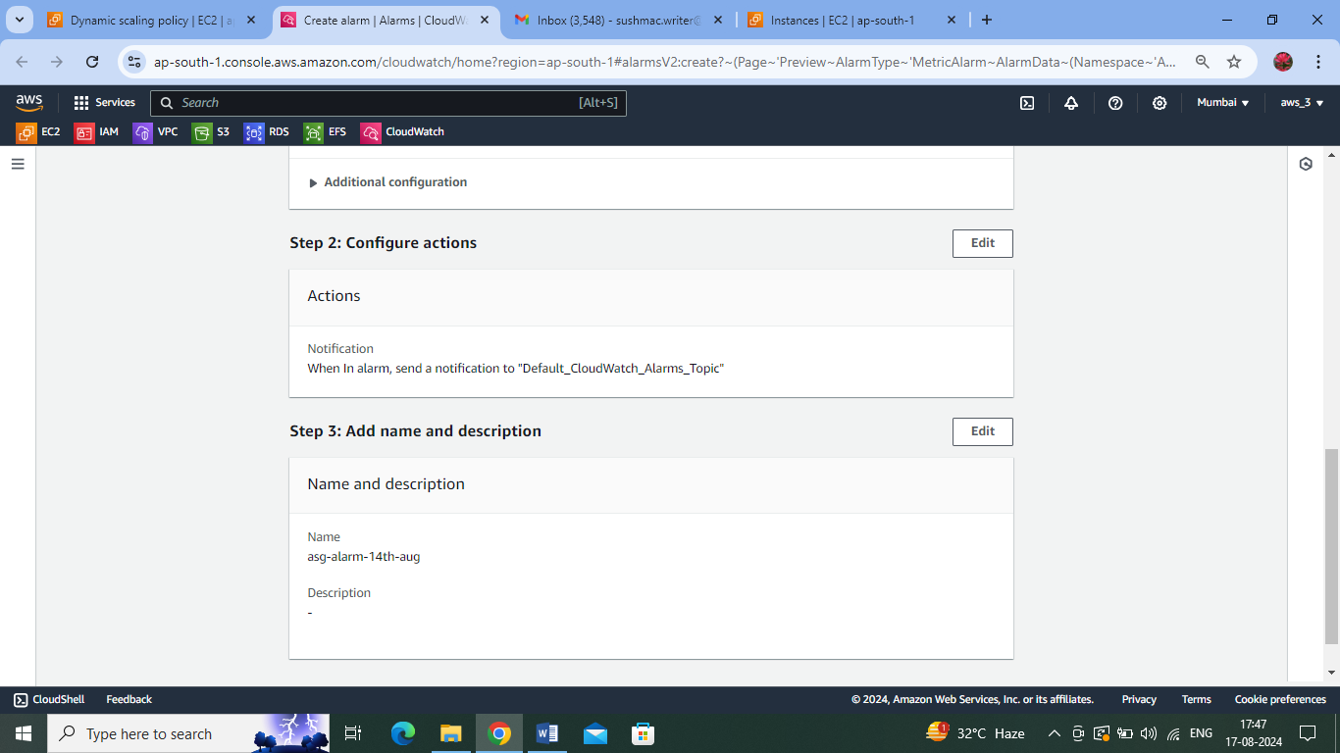

Creating a Step-Scaling Policy to Associate with the Cloud Watch Alarm:

Attached the Cloud Watch Alarm

1. Adding one EC2 unit when threshold crosses 80% of CPU Utilisation.

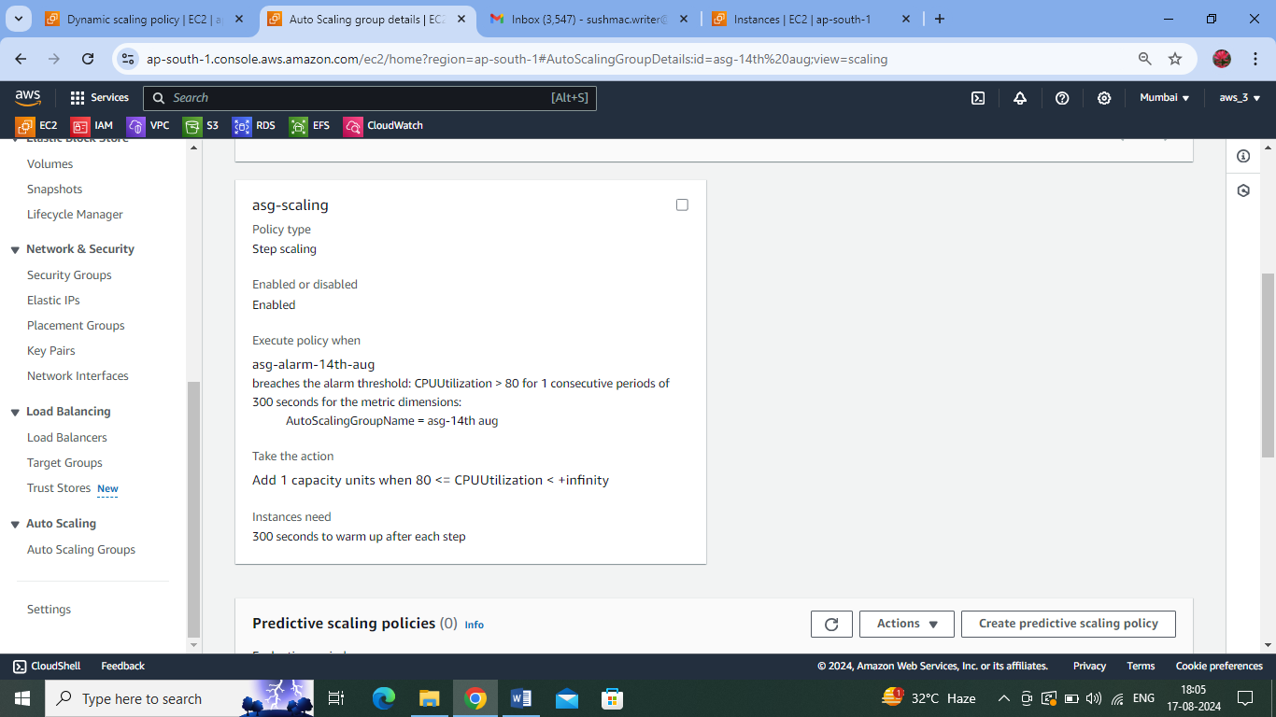

Adding the above Automatic Scaling policy to the ASG action under the Cloud Alarm :

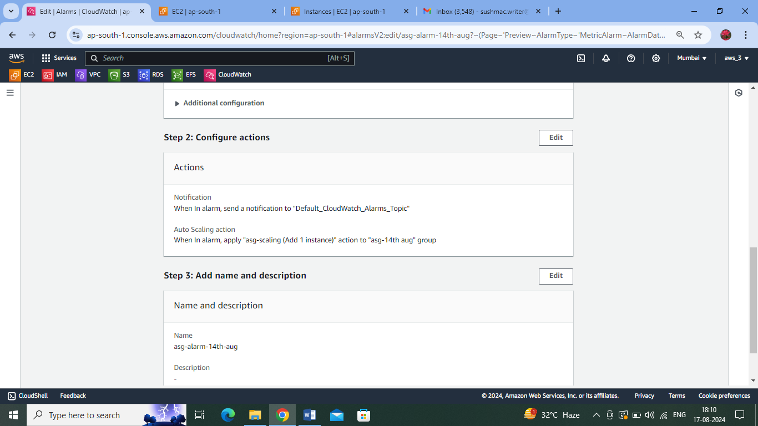

Creating Second Alarm – with less than 60% CPU Utilization:

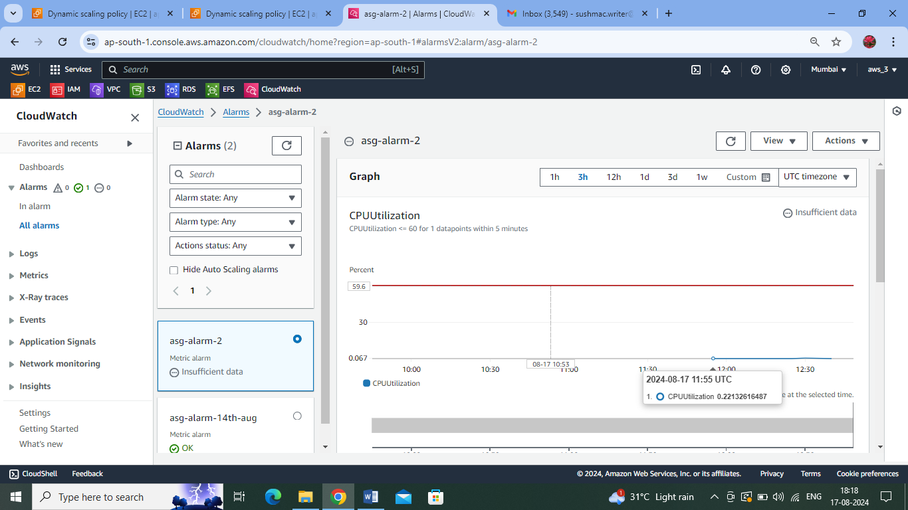

Creating Second AS Policy – to remove one instance when the threshold of CPU Utilization becomes less than or equal to 60%:

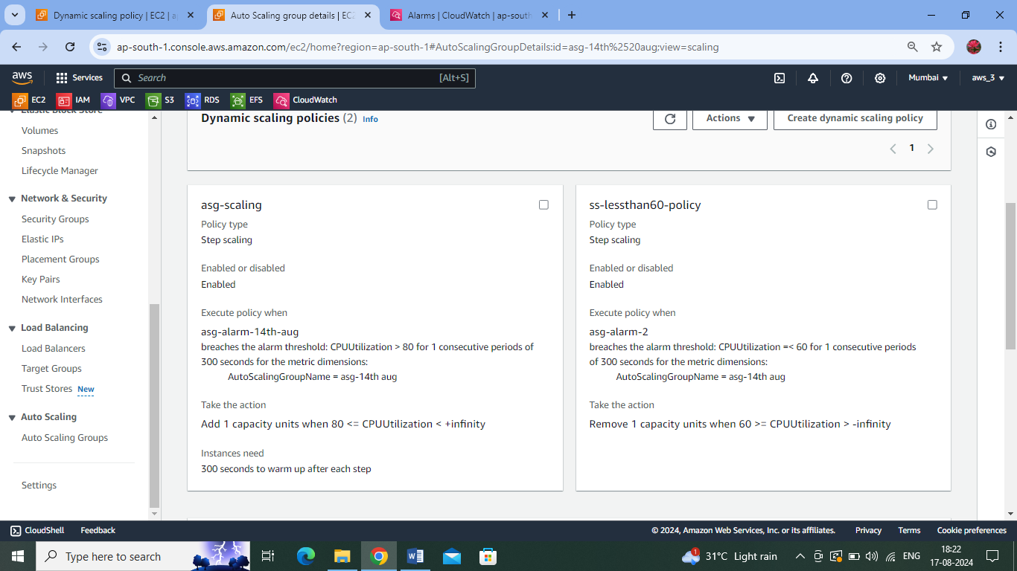

Installing Stress library to create artificial stress on the EC2 instances:

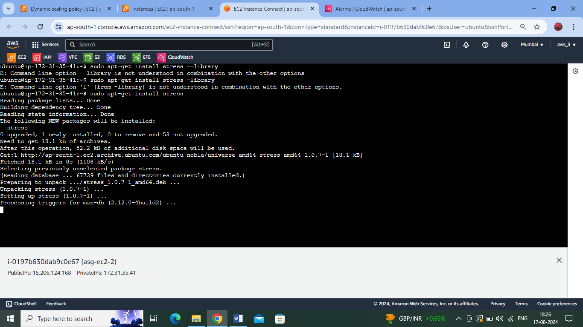

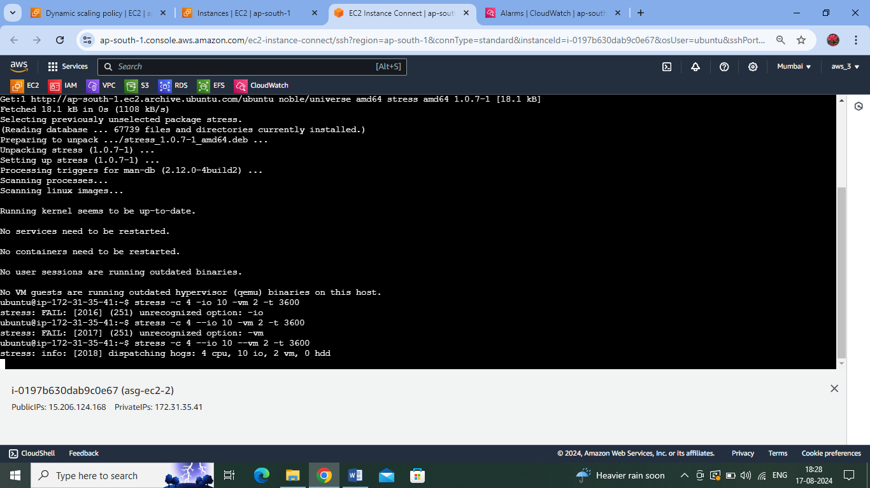

Alarm notification received for crossing 80% threshold of CPU Utilisation:

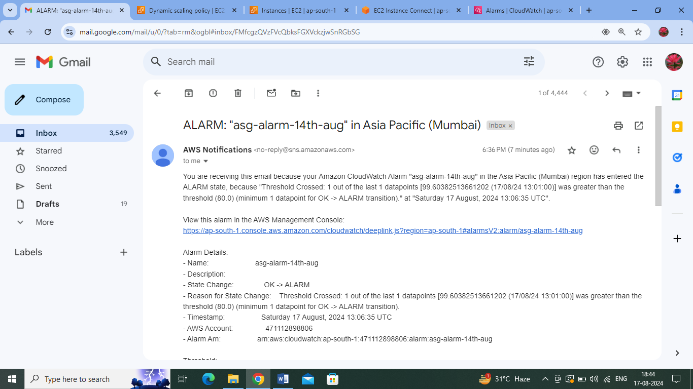

Hence one new EC2 instance is being added – as per the AS policy created :

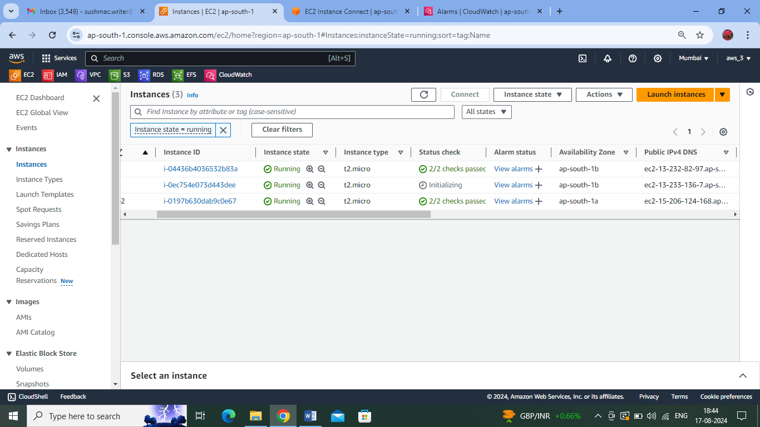

Once the stress is removed, I get the following notification for threshold of CPU Utilisation being below 60%:

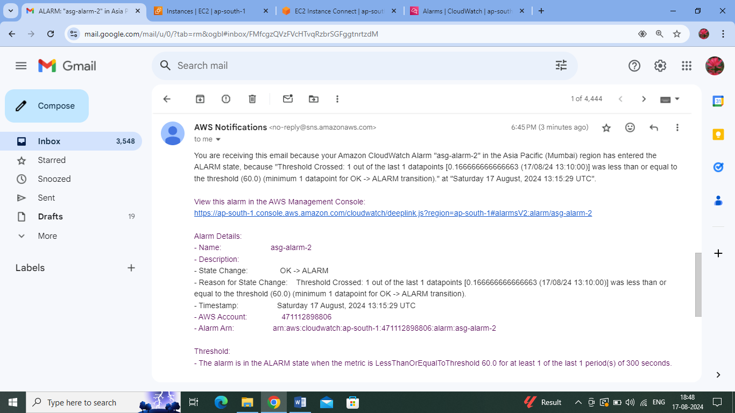

One instance is shut down as per the Scaling policy – threshold <=60% of CPU Utilisation:

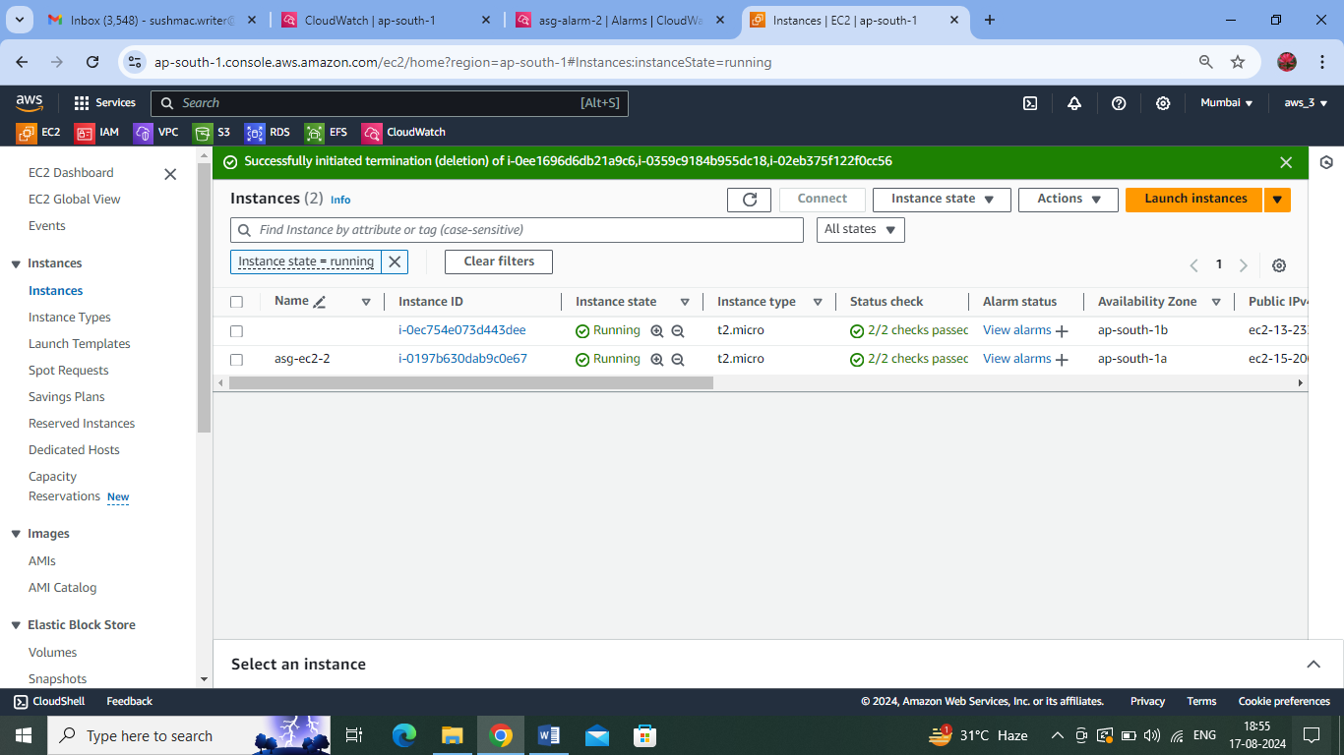

Again, as per As policy another EC2 instance is also removed :

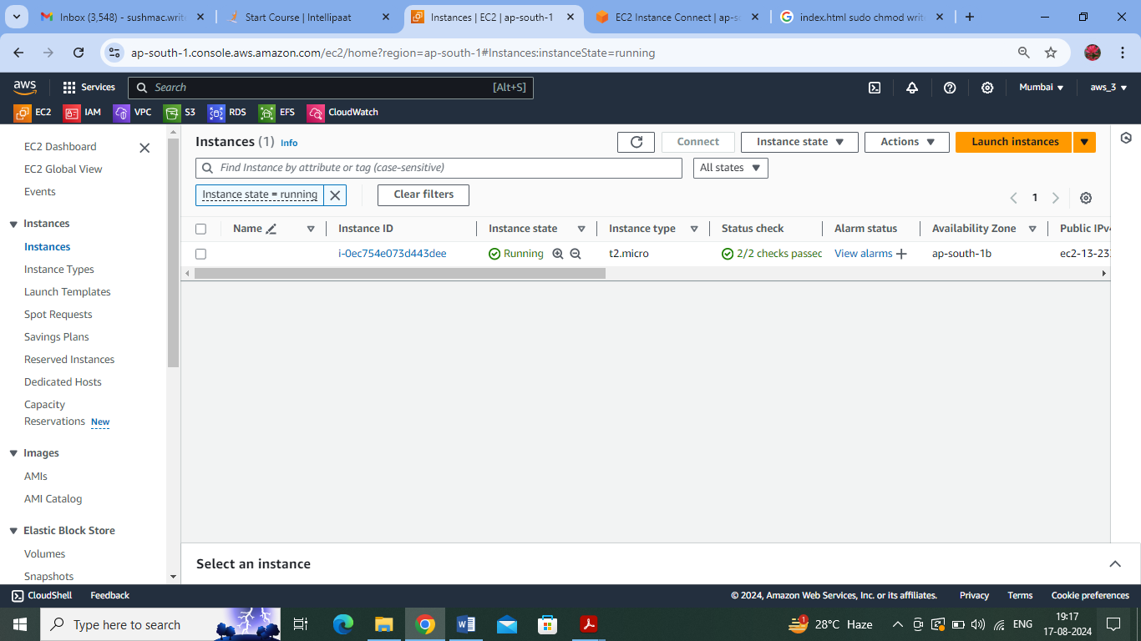

Created stress again, an additional instance was generated.

Using the load balancer domain name. In round robin fashion , switching happened between the servers to balance out the load.

